26.79: a) 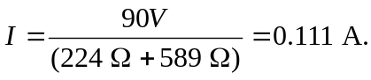
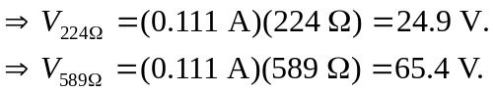
b) 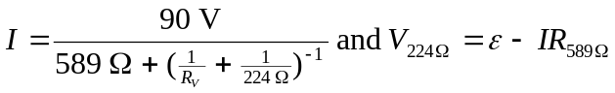
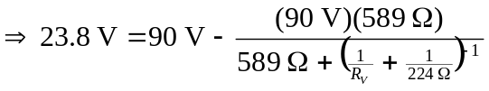
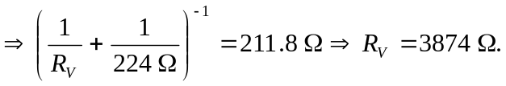
c) If the voltmeter is connected over the  resistor, then:
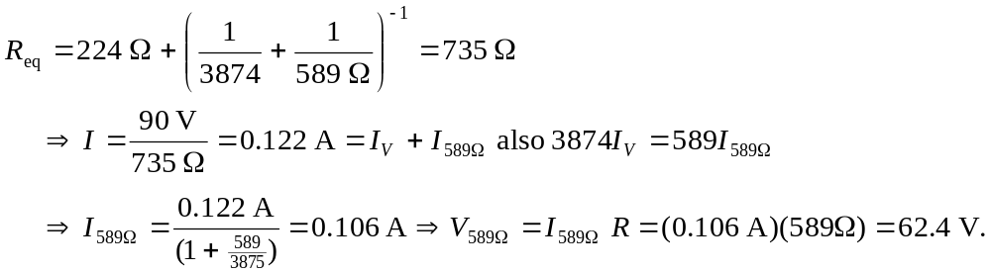
d) No. From the equation in part (b) one can see that any voltmeter with finite resistance 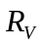 placed in parallel with any other resistance will always decrease the measured voltage.

